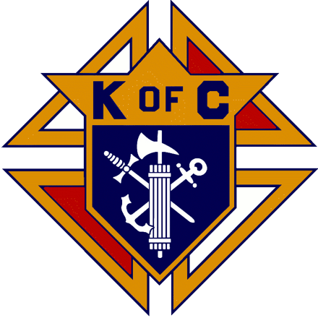

Community / Veterans Pancake Breakfast

November 10 after Sunday morning Masses

Come join us for breakfast and fellowship in the PAC

The Knights from St Henry Council would be happy to have a conversation with you on what we do to make a difference for the parish and community.

If you are a Catholic male over the age of 18 (or know of one) and not in the Knights of Columbus, we hope the **5 reasons** below will encourage you to join this great fraternal organization of the Catholic Church that is founded on the principles of Charity, Unity, Fraternity, and Patriotism.

**1. The Heartbeat of the Knights of Columbus is Service**. The Knights are one the largest charitable organizations in the world. Through a variety of fundraisers throughout the year, the Knights raise financial support for many charities, including the Special Olympics and the Global Wheelchair Mission.

**2. The Knights of Columbus Supports the Catholic Church** because the order is composed of a fraternity of 1.8 million Catholic Men. From the founding of the Knights of Columbus by Venerable Michael J. McGivney, the Knights have been a foundation of support for the Catholic Church.

**3. The Knights of Columbus are** **Pro-Family**. Since the traditional family is composed of the husband, wife, and children, the Knights see them as the core, foundation, and fabric for all of society. Although the council meetings are for the members, many councils sponsor activities with the family in mind. It’s a great time to gather together as Catholic Christians and members of the Mystical Body of Christ. Realizing that the youth are an integral part of society, the Knights seek to foster the development of the child from adolescence to adulthood.

**4. The Knights of Columbus are strongly and devoutly** **Pro-Life.** Following the teachings of the Catholic Church, they believe that Life begins at conception and ends in natural death.

**5. The Knights of Columbus are Faithful to the Catholic Church** by being obedient to the teachings of the Church, its Bishops and Priests, and showing fidelity to the See of Peter. As faithful Catholics, the Knights foster and develop Vocations to the Priesthood, Religious Life, and Holy Matrimony.

Please contact any Knight or one of the following should you have an interest in making a difference as a Knight:

Please contact any Knight or one of the following for more information:

Bob Raney Tom Wendeln

Past Grand Knight Grand Knight

(937) 409-2099 (937) 901-3998

[Bob.Raney@ymail.com](mailto:Bob.Raney@ymail.com) [gobuckstcw1@yahoo.com](mailto:gobuckstcw1@yahoo.com)